Supply Base Report:

SIA PALLETERIES

Choose audit type here

www.sbp-cert.org

Completed in accordance with the Supply Base Report Template Version 1.3

For further information on the SBP Framework and to view the full set of documentation see www.sbp-cert.org

Document history
Version 1.0: published 26 March 2015
Version 1.1 published 22 February 2016
Version 1.2 published 23 June 2016
Version 1.3 published 14 January 2019; re-published 3 April 2020

© Copyright Sustainable Biomass Program Limited 2020

Contents
1 Overview 1
2 Description of the Supply Base 2
2.1 General description 2
2.2 Actions taken to promote certification amongst feedstock supplier 9
2.3 Final harvest sampling programme 10
2.4 Flow diagram of feedstock inputs showing feedstock type [optional] 10
2.5 Quantification of the Supply Base 10
3 Requirement for a Supply Base Evaluation 12
4 Supply Base Evaluation 13
4.1 Scope 13
4.2 Justification 13
4.3 Results of Risk Assessment 14
4.4 Results of Supplier Verification Programme 14
4.5 Conclusion 14
5 Supply Base Evaluation Process 16
6 Stakeholder Consultation 17
6.1 Response to stakeholder comments 17
7 Overview of Initial Assessment of Risk 18
8 Supplier Verification Programme 19
8.1 Description of the Supplier Verification Programme 19
8.2 Site visits 19
8.3 Conclusions from the Supplier Verification Programme 20
9 Mitigation Measures 22
9.1 Mitigation measures 22
9.2 Monitoring and outcomes 22
10 Detailed Findings for Indicators 24
11 Review of Report 25
11.1 Peer review 25
11.2 Public or additional reviews 25
12 Approval of Report 26
13 Updates 27
13.1 Significant changes in the Supply Base 27
13.2 Effectiveness of previous mitigation measures 27
13.3 New risk ratings and mitigation measures 27
13.4 Actual figures for feedstock over the previous 12 months 27
13.5 Projected figures for feedstock over the next 12 months 28

Overview
On the first page include the following information:
Producer name: SIA PALLETERIES
Producer location: Zala street 6, Kuldiga, LV-3301, Latvia
Geographic position: 56.968391, 21.930756
Primary contact: Arita Upmale; +371 26409659; e-mail:
arita@palleteries.lv
Company website: https://www.palleteries.lv
Date report finalised: 1. February 2021
Close of last CB audit: [Date and location of the closing meeting CB]
Name of CB: Nepcon SIA]
Translations from English: NA
SBP Standard(s) used: SBP Standard 2-V1.0 ; SBP Standard 4-V1.0. ; SBP Standard 5-V1.0 (instructions documents 5E;ID5E 1.1
Weblink to Standard(s) used: https://sbp-cert.org/documents/standards-documents/standards
SBP Endorsed Regional Risk Assessment: [Reference endorsed RRA or ‘not applicable’]
Weblink to SBE on Company website: https://www.palleteries.lv

Indicate how the current evaluation fits within the cycle of Supply Base Evaluations
Main (Initial)  Evaluation | First  Surveillance | Second Surveillance | Third  Surveillance | Fourth  Surveillance
X | ☐ | ☐ | ☐ | ☐

Description of the Supply Base

General description
SIA Palleteries in two sawmills production palleten timber of round wood. Processing get by-products ( wood chips and sawdust) .

Biomass proportion by certification status:
Delivery Period: January 1. – December 31. 2020

SBP-compliant primary feedstock: 100% ( 2 suppliers)
SBP-compliant secondary feedstock 100% (from own sawmills shavings and chips after processing)

SBP-compliant tertiary feedstock: 0 %
Controlled feedstock: ~0% (0 suppliers)
SBP-noncompliant feedstock: 0 %
Species: Picea abies (L.) H. Karst.; Pinus sylvestris (L.); Alnus glutinosa (L.) Gaertn.; Alnus incana (L.) Moench, Populus tremula (L.); Betula pendula (Roth); Betula pubescens (Ehrh..

Information about LATVIAN forest resources
Forest cover
Latvia has the fourth highest forest cover among all EU countries, surpassed only by Finland (77 %), Sweden (76 %) and Slovenia (63 %). Forests in Latvia take total forest ares 3 597 000 hectares of land, or 53% of the country’s territory. The Latvian state owns around one-half of the country’s forests, while most of the rest of the forest belongs to approximately 135,000 private owners. The amount of forestland, moreover, is constantly expanding, both naturally and thanks to afforestation of infertile land and other land that is not used for agriculture.
(https://www.zm.gov.lv/20.)

Forest Area by Dominant Species. Whole country, 2020
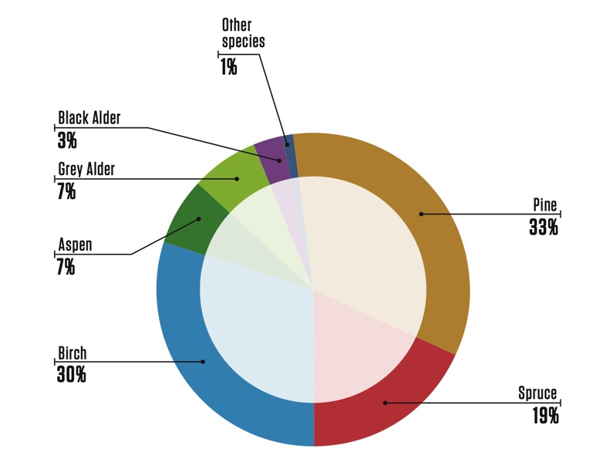
(State Forest Service data in Latvian Forest Sector in Facts & Figures 2020, published by the Ministry of Agriculture:
(https://www.zm.gov.lv/20.) )
An average of approximately 11 million m3 of timber have been harvested each year in Latvia’s forests during the past decade. That is less than the annual increment, and so forestry in Latvia can be described as sustainable. (State Forest Service data in Latvian Forest Sector in Facts & Figures 2020, published by the Ministry of Agriculture: (https://www.zm.gov.lv/20.)
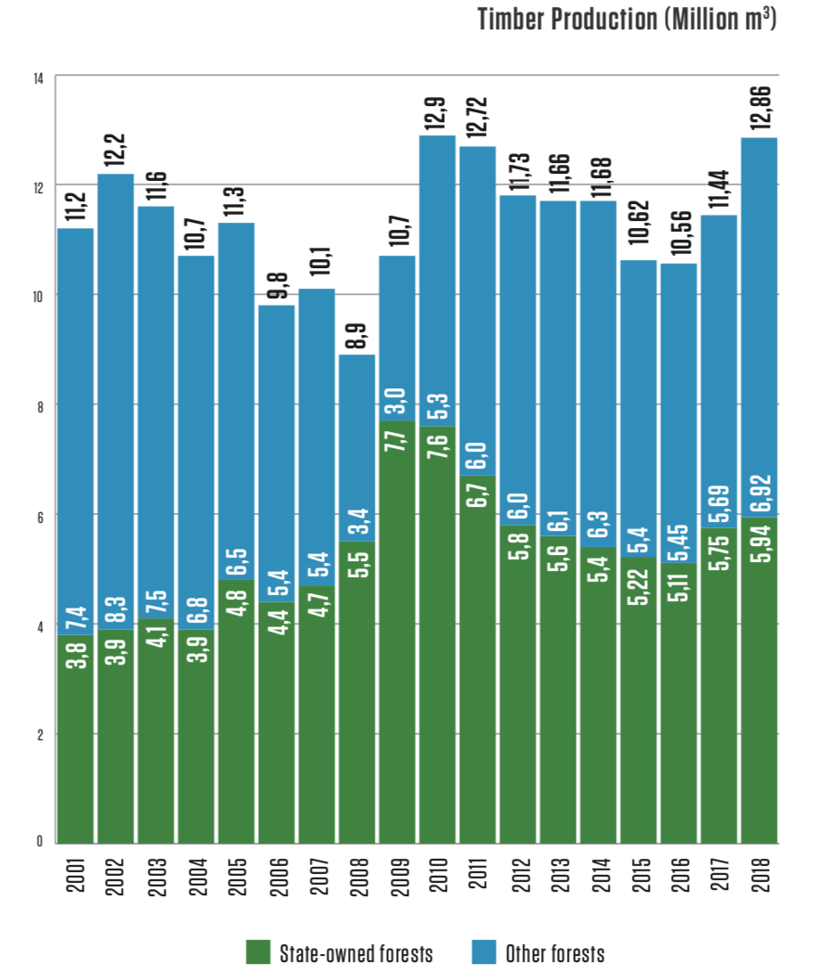
Ownership
The Latvian state owns around one-half of the country’s forests, while most of the rest of the forest belongs to approximately 135,000 private owners. Forest ownership by status, 2020 (State Forest Service).
(https://www.zm.gov.lv/20.)
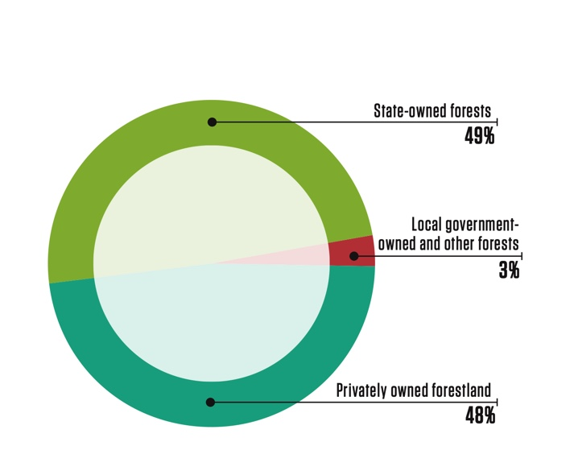

Management practices
The forest sector in Latvia is under the supervision of the Ministry of Agriculture. It works with stakeholders to draft forest policies, development strategies for the sector, as well as regulations on forest management, the use of forest resources, environment protection and hunting. www.zm.gov.lv. The State Forest Service, under the Ministry of Agriculture, is the responsible agency for supervising how the provisions of the laws and regulations are observed in forest management irrespective of the ownership type. www.vmd.gov.lv. State-owned forests are managed by Stock Company “Latvian State Forests”, which was established in 1999. It implements the state’s interests in terms of preserving and increasing the value of the forest and enhancing the contributions of the forest to the national economy.
Limitations on economic activity apply to 28,2% of Latvia’s forests at this time, and most of this territory is owned by the state. 683 especially protected environmental territories have been set aside to protect nature. Many are included in the unified and pan-European NATURA 2000 network of protected territories.
There are various restrictions on economic activity in the specially protected areas, ranging from a complete ban on forestry throughout the calendar year to a ban on tree felling in certain months of the year or on specific conditions for felling. Overall, in around 13.5% of Latvia’s forests there are some form of forest management restrictions in place, in 3.4% of these areas all forest management activities are prohibited.
Due to the dramatic increase in forest cover in the last 100 years, the current proportion of old-growth forests in Latvia is low and as such, a major challenge of forest conservation in Latvia is to ensure that such old- growth forests and features are protected and allowed to develop. www.lvm.lv
According to the State Forest Service data, the total growing stock volume was 682 million m3 in 2020. Latvian forest land consists of:
Forest land consists of:
- Forests 3,292 ha (91,5%);
- Marshes 0,125 ha (3,5%);
- Glades 0,030 ha (0,8%);
- Flooded areas 0,042 ha (1,2%);
- Objects of infrastructure 0,097 ha (2,7%);
- Other forest land 0,011 ha (0,3%).
(https://www.zm.gov.lv/20.)
Forest Area by Dominant Species. Whole country, 2020
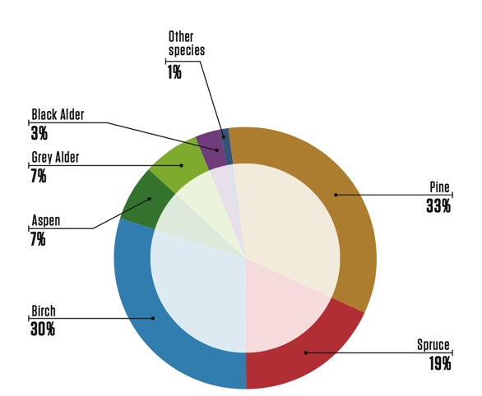

(https://www.zm.gov.lv/)
Timber production by types of cuts, by volume produced:
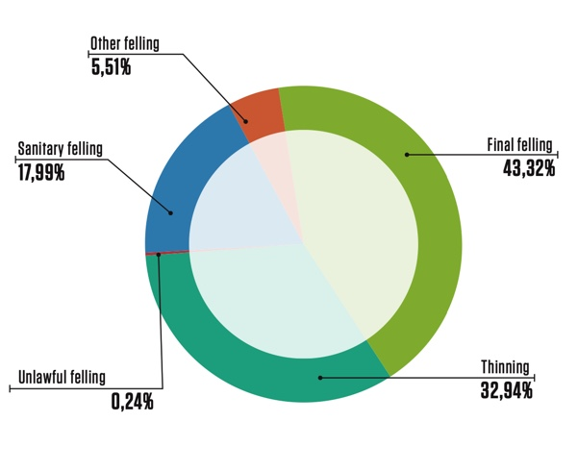
(https://www.zm.gov.lv.)

The field of forestry
In Latvia, the field of forestry is supervised by the Ministry of Agriculture, which in cooperation with stakeholders of the sphere develops forest policy, development strategy of the field, as well as drafts of legislative acts concerning forest management, use of forest resources, nature protection and hunting (www.zm.gov.lv). Implementation of requirements of the national law and regulations notwithstanding the type of tenure is carried out by the State Forest Service under the Ministry of Agriculture (State Forest Services: www.vmd.gov.lv). Management of the state-owned forests is performed by the Joint Stock Company “Latvia’s State Forests”, established in 1999. The enterprise ensures implementation of the best interests of the state by preserving value of the forest and increasing the share of forest in the national economy (www.lvm.lv).
Socio-Economic setting
According to the Latvian Ministry of Agriculture, the forest sector is one of the cornerstones of the national economy at this time. Forestry, wood processing and furniture manufacturing represented 5,1% of GDP in 2018, while exports amounted to EUR 2,645 billion – 21% of all exports. There is no parish in Latvia with no larger or smaller wood processing company. Often these are the most important employers in the surrounding area, thus being the main pillar of support for local economies and residents.
The forest industry has always been Latvia’s export leader. About 71 % of forestry-sector output is exported. The foreign trade balance of the Latvian woodworking industry is positive, having reached EUR 1.7 billion in 2018. In 2018, the value of forest product exports was EUR 2.645 billion, 17 % higher than in 2017, while the value of forest products import was EUR 939 million. The main export destinations traditionally are the EU countries: the United Kingdom, Germany, and Sweden that together account for more than 40% of Latvia’s wooden product exports.
Biological diversity
In historical terms, the intensive use of Latvia’s forests for economic purposes began comparatively later than in many other European countries, and that has allowed us to preserve extensive biological diversity. Limitations on economic activity apply to 28,2% of Latvia’s forests at this time, and most of this territory is owned by the state. 683 especially protected environmental territories have been set aside to protect nature. Many are included in the unified and pan-European NATURA 2000 network of protected territories.
In order to protect highly endangered species and biotopes located without the designated protected areas, if a functional zone does not provide that, micro-reserves are established. In 2018, the State Forest Service has established and maintained 2417 micro-reserves in forest lands with a total area of 43.7 thousand. ha, of which 91% of micro-restricted areas are in state forests, 7% - in private forests and 2% - in municipal forests. Identification and protection planning of biologically valuable forest stands is carried out continuously.
Moreover, there are national laws in place designed for the preservation of biological diversity and general nature protection requirements must be followed during the forest management activities. These are binding to all forest managers. These requirements stipulate that selected old and large trees, dead wood, underwood trees and shrubs, land cover around wet micro-lowlands (terrain depressions) are to be preserved at felling, thus providing habitat for many organisms.
Latvia has been a signatory of the CITES Convention since 1997. CITES requirements are respected in forest management, although there are no species included in the CITES lists in Latvia.
Forest and community
Areas where recreation is one of the main forest management objectives add up to 8 % of the total forest area or 272 960 ha (2019). Observation towers, educational trails, natural objects of culture history value, picnic venues: they are just a few of recreational infrastructure objects available to everyone free of charge. Special attention is devoted to creation of such areas in state-owned forests. Recreational forest areas include national parks (excluding strictly protected areas), nature parks, protected landscape areas, protected dendrological objects, protected geological and geomorphologic objects, nature parks of local significance, the Baltic Sea dune protection zone, protective zones around cities and towns, forests within administrative territory of cities and towns. Management and governance of specially protected natural areas in Latvia is co-ordinated by the Nature Conservation Agency under the Ministry for Environmental Protection and Regional Development.
Forest Sector / Statical pages
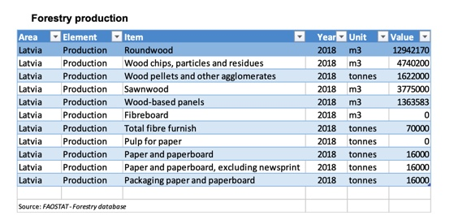
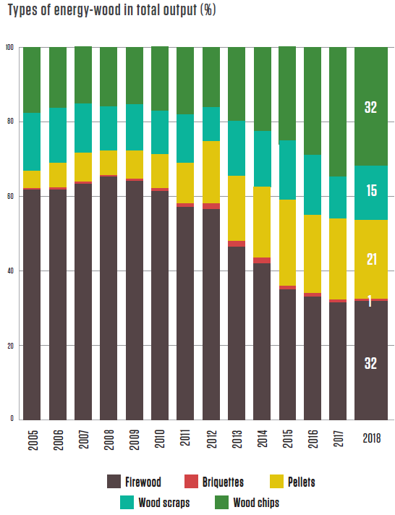
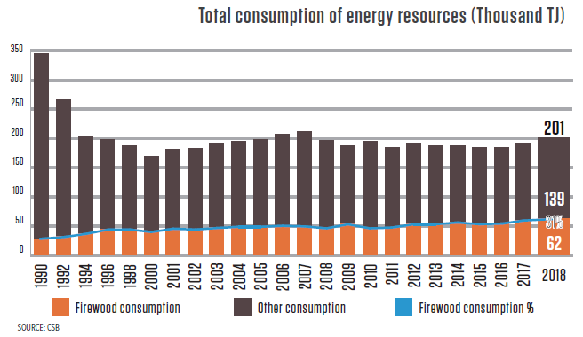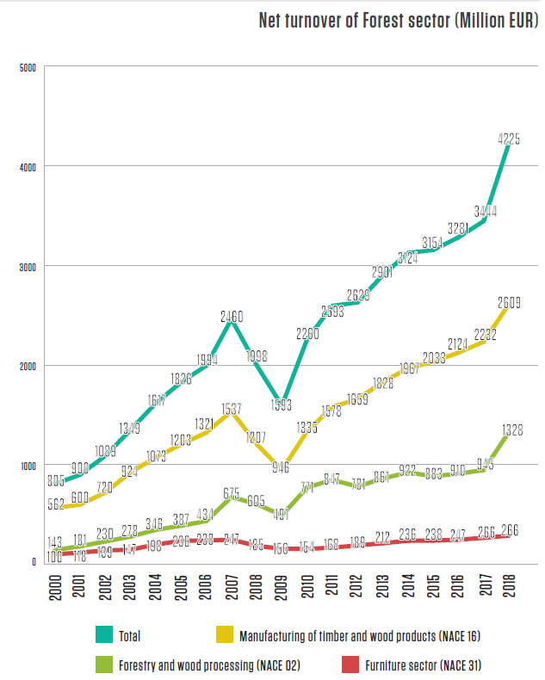

Latvia’s Import-Export Balance (Million EUR), 2018
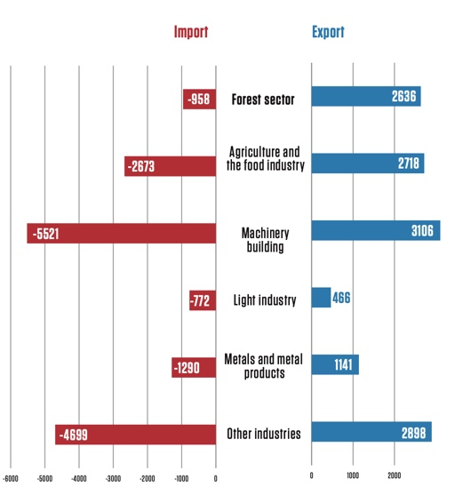

Certification
All forest area of Latvijas Valsts Meži as well as some part of forests in private and other ownership are FSC or PEFC certified. From a total forest area more than a hald of Latvian forest ares have been certified according to FSC 1,24 milj/ha or PEFC 1,72 milj/ha certification scheme. Both the FSC and PEFC in totally 3,29 milj/ ha systems have found their way into Latvia.

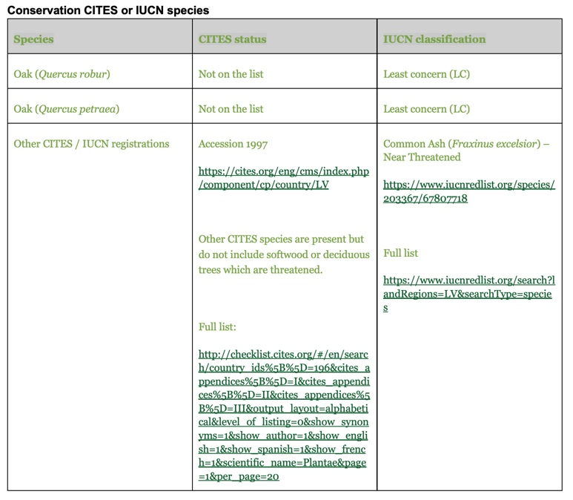

Actions taken to promote certification amongst feedstock supplier
As a priority, materials for the production of SBP pellets are purchased from suppliers certified by FSC or PEFC as the certified wood. The company policy is directed at cooperation with certified suppliers. Feedstock ( woodchips) is comprised of wood by-products from the suppliers’ production of their primary product. For this reason, uncertified and new suppliers are encouraged to have their primary product certified and put the leftovers to good use. Decision of the company management is to assess overall supply risks and decrease these in accordance with SBP risk assessment in Latvia, both for FSC Controlled and uncertified primary and secondary feedstock, so that the entire amount meets at least the SBP Compliant biomass or SBP Controlled Biomass status.

Final harvest sampling programme
The amount of biomass is a by-product of the recycled raw material from the same two sawmills. The primary raw material is sourced from FSC and PEFC roundwood suppliers. The largest amount of raw materials is delivered from the Latvian State Forests with which a contract is concluded, according to the amount auctioned.

Flow diagram of feedstock inputs showing feedstock type [optional]
Insert flow diagram.

Quantification of the Supply Base
Provide metrics for the Supply Base including the following. Where estimates are provided these shall be justified.

Supply Base
- Total Supply Base area (ha): Latvia 3.291 milj/ha
- Tenure by type (ha): Latvia 1,52 milj/ha state forests; 1,770 milj/ha private forests and Local Government 0,102 milj/ha,
- Forest by type (ha): Latvia 3.291 milj/ha hemi boreal
- Forest by management type (ha): Managed, partly natural forests 3.291 milj/ ha
- Certified forest by scheme (ha): Latvia FSC ~1,24 milj/ ha are certified according to FSC and/or ~1,72 milj/ha PEFC certification systems.

Feedstock
- Total volume of Feedstock: 1 – 200,000 tonnes
- Volume of primary feedstock: 1-200,000 tonnes
- List percentage of primary feedstock (g), by the following categories. - Subdivide by SBP-approved Forest Management Schemes:
  - Certified to an SBP-approved Forest Management Scheme- 100%FSC apjoms
  - Not certified to an SBP-approved Forest Management Scheme- 0%
- List all species in primary feedstock, including scientific name
Picea abies (L.) H. Karst.; Pinus sylvestris (L.); Alnus glutinosa (L.) Gaertn.; Alnus incana (L.) Moench, Populus tremula (L.); Betula pendula (Roth); Betula pubescens (Ehrh.)
- Volume of primary feedstock from primary forest- 0%
- List percentage of primary feedstock from primary forest (j), by the following categories. Subdivide by SBP-approved Forest Management Schemes:
  - Primary feedstock from primary forest certified to an SBP-approved Forest Management Scheme- 0%
  - Primary feedstock from primary forest not certified to an SBP-approved Forest Management Scheme- 0%
- Volume of secondary feedstock: specify origin and type - 1 – 200,000 tonnes ( chips and sawdust from Latvia 100%...
- Volume of tertiary feedstock: specify origin and composition – 0%.

* Compelling justification would be specific evidence that, for example, disclosure of the exact figure would reveal commercially sensitive information that could be used by competitors to gain competitive advantage. State the reasons why the information is commercially sensitive, for example, what competitors would be able to do or determine with knowledge of the information.
Bands for (f) and (g) are:
1. 0 – 200,000 tonnes or m³
2. 200,000 – 400,000 tonnes or m³
3. 400,000 – 600,000 tonnes or m³
4. 600,000 – 800,000 tonnes or m³
5. 800,000 – 1,000,000 tonnes or m³
6. >1,000, 000 tonnes or m³

Bands for (h), (l) and (m) are:
            - 0%-19%
            - 20%-39%
            - 40%-59%
            - 60%-79%
            - 80%-100%
NB: Percentage values to be calculated as rounded-up integers.

Requirement for a Supply Base Evaluation
SBE completed | SBE not completed
 | X

Supply Base Evaluation

Scope
N/A

Justification
N/A

Results of Risk Assessment
N/A

Results of Supplier Verification Programme
N/A.

Conclusion
N/A

Supply Base Evaluation Process
N/A

Stakeholder Consultation
N/A

Response to stakeholder comments
Provide a summary of all stakeholder comments received and how the comments were taken into consideration in the SBE process.
Comment 1:
Response 1:
Comment 2:
Response 2:

Overview of Initial Assessment of Risk
N/A
The below table offers a summary of risk assessment. The risk assessment was performed based on theoretical information that is obtained from laws, scientific materials, publications, State Forest Service data. After the publication of the risk assessment, SIA Palleteries started on-site verification of two identified risks. The results are shown in Paragraphs 7 and 8.
.
Table 1. Overview of results from the risk assessment of all Indicators (prior to SVP)
Indicator | Initial Risk Rating |  |  |  | Indicator | Initial Risk Rating
 | Specified | Low | Unspecified |  |  | Specified | Low | Unspecified
1.1.1 |  | X |  |  | 2.3.1 |  | X
1.1.2 |  | X |  |  | 2.3.2 |  | X
1.1.3 |  | X |  |  | 2.3.3 |  | X
1.2.1 |  | X |  |  | 2.4.1 |  | X
1.3.1 |  | X |  |  | 2.4.2 |  | X
1.4.1 |  | X |  |  | 2.4.3 |  | X
1.5.1 |  | X |  |  | 2.5.1 |  | X
1.6.1 |  | X |  |  | 2.5.2 |  | X
2.1.1 | x |  |  |  | 2.6.1 |  | X
2.1.2 | x |  |  |  | 2.7.1 |  | X
2.1.3 |  | X |  |  | 2.7.2 |  | X
2.2.1 |  | X |  |  | 2.7.3 |  | X
2.2.2 |  | X |  |  | 2.7.4 |  | X
2.2.3 |  | X |  |  | 2.7.5 |  | X
2.2.4 |  | X |  |  | 2.8.1 | x
2.2.5 |  | X |  |  | 2.9.1 |  | X
2.2.6 |  | X |  |  | 2.9.2 |  | X
2.2.7 |  | X |  |  | 2.10.1 |  | X
2.2.8 |  | X
2.2.9 |  | X

Supplier Verification Programme

Description of the Supplier Verification Programme
N/A

Site visits
N/A

Conclusions from the Supplier Verification Programme
N/A

Mitigation Measures

Mitigation measures
N/A

Monitoring and outcomes
N/A

Detailed Findings for Indicators
N/A

Review of Report

Peer review
If an external peer review of this report was done prior to finalisation, describe the process that was followed and the competency of the parties involved.

Public or additional reviews
If another type of external review was done prior to finalisation of this report (e.g. publication for comments by stakeholders, NGOs, or other independent third parties), describe the process here.

Approval of Report
Approval of Supply Base Report by senior management
Report Prepared by: | Arita Upmane | Prodaction manager | 8.2.2021.
 | Name | Title | Date
The undersigned persons confirm that I/we are members of the organisation’s senior management and do hereby affirm that the contents of this evaluation report were duly acknowledged by senior management as being accurate prior to approval and finalisation of the report.
Report approved by: | Edijs Ošs | Chairman of the Board | 8.02.2021.
 | Name | Title | Date
Report approved by: | Ivars Linde | Technical director | 8.02.2021.
 | Name | Title | Date

Updates
Note: Updates should be provided in the form of additional pages, either published separately or added to the original public summary report.

Significant changes in the Supply Base
Provide a description of any significant changes to the supply base.

Effectiveness of previous mitigation measures
For each mitigation measure identified during the evaluation, give a detailed account of whether the measures were shown to be effective or not.

New risk ratings and mitigation measures
Provide an update of risk ratings for all relevant Indicators.

Actual figures for feedstock over the previous 12 months

Using the categories in Section 2.5 ‘Quantification of the Supply Base’ (above), give an update on the actual figures for the previous 12 month period. Volume may be shown in a banding between XXX,000 to YYY,000 tonnes or m³ if a compelling justification is provided*
80% of raw materials(packaging blocks) from which biomass is produced are supplied from Latvia State Forests (FSC and PEFC certified) and a small part from other certifield suppliers.

Reference period 1. January 2020 – 31. December 2020.
Total volume of Feedstock 1 – 200,000 tonnes
Volume of primary feedstock: 1- 200,000 tonnes
Sawmill residues 30,000 – 40,000 tonnes ( chips and sawdust from Latvia)
Total wood chips – 65 % -70 %
Total sawdust – 30 % - 35 %
As SBR is publicly available document not only for the purchasers of the product but also for others interested, the management has decided to display the data as limit indicators in order not to display the exact data of raw materials and production output. The exact volume has not been shown by the reason of commercial sensibility. The exact volume data is provided to the buyer with a SAR report.

Projected figures for feedstock over the next 12 months
Using the categories in Section 2.5 ‘Quantification of the Supply Base’ (above), give an updated projection for the coming 12 month period. Volume may be shown in a banding between XXX,000 to YYY,000 tonnes Reference period
80% of raw materials(packaging blocks) from which biomass is produced are supplied from Latvia State Forests (FSC and PEFC certified) and a small part from other certifield suppliers.

1. January 2021 – 31. December 2021.
Total volume of Feedstock 1 – 200,000 tonnes
Volume of primary feedstock: 1 – 200,000 tonnes
Sawmill residues 30,000– 50,000 tonnes ( chips and sawdust from Latvia)
Total wood chips – 65 % -70 %
Total sawdust – 30 % - 35 %

As SBR is publicly available document not only for the purchasers of the product but also for others interested, the management has decided to display the data as limit indicators in order not to display the exact data of raw materials and production output. The exact volume has not been shown by the reason of commercial sensibility. The exact volume data is provided to the buyer with a SAR report.

